# Moodle Skydrive plugin review

The integration with Moodle doesn’t seem to be working

The plugin installed on **moodle-test** was already installed.

From the file *version.php* on **moodle-test**, the version of the plugin on the server seems more recent than the one available online.

The plugin seems to be configures correctly.

The plugin was enabled

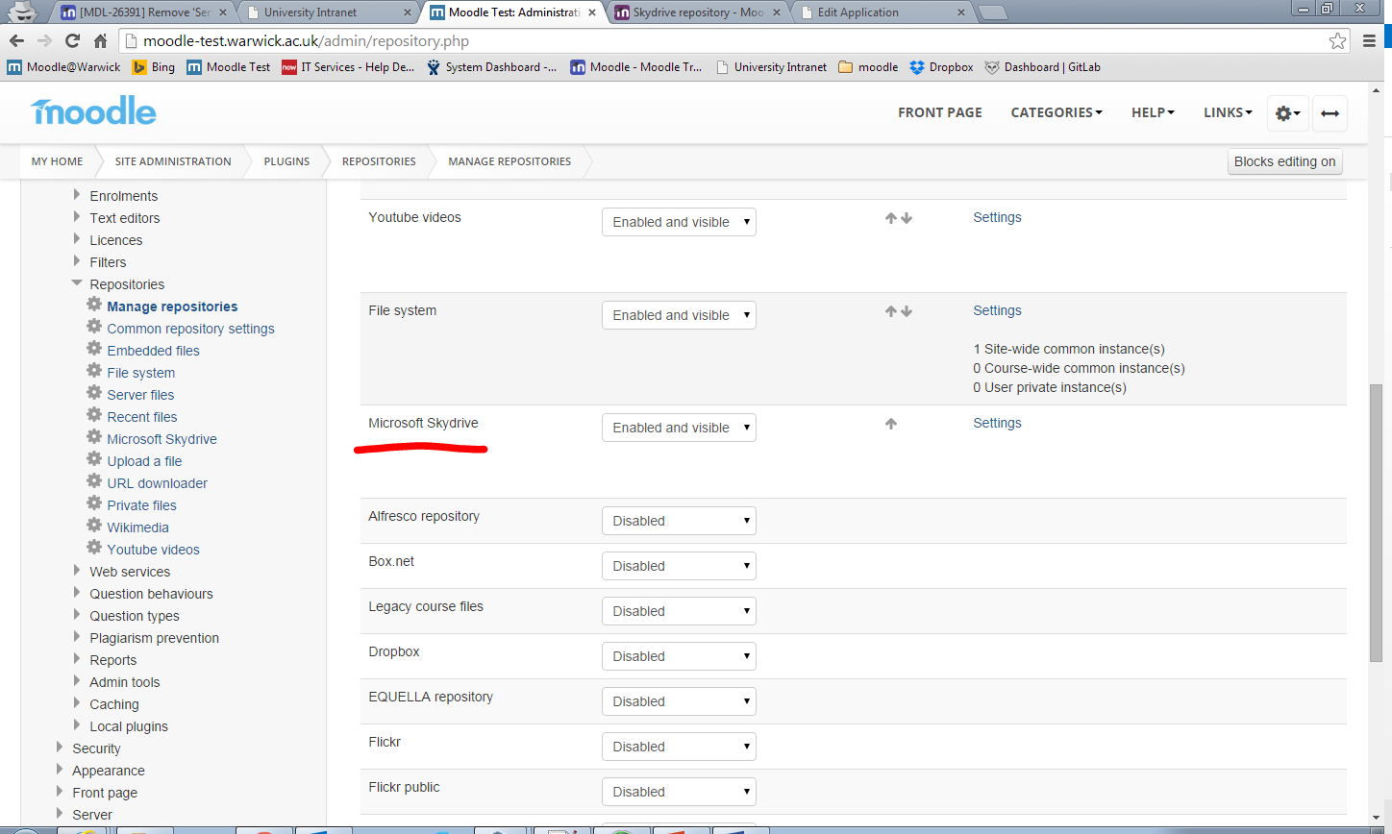

The required Client ID and secret were set.

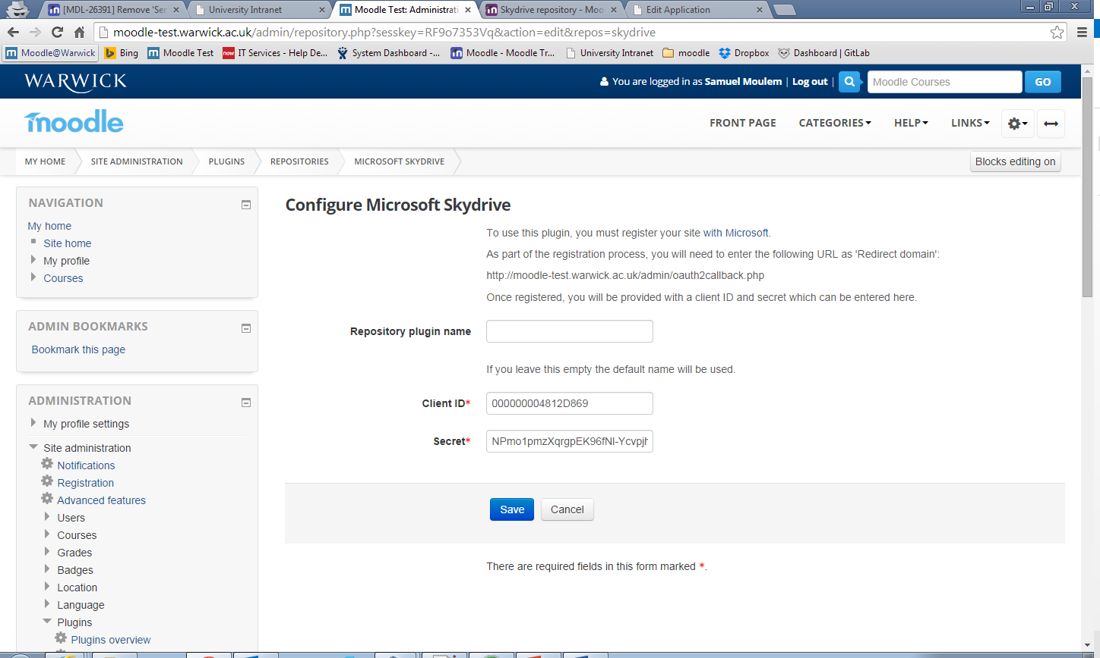

However when one tries to use the plugin, Moodle comes back with an error

